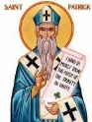
OUR LADY OF LOURDES, ROTTINGDEAN and ST. PATRICK’S, WOODINGDEAN
Eastfield, Steyning Road, Rottingdean BN2 7GA Website: www.ololandstp.org
Office email: rottingdean@abdiocese.org.uk Office Tel: 01273 302903
Priest: Fr. Maksym Krat (Maksym.krat@abdiocese.org.uk)
Deacon: Rev. Bernard Hill (07505 460888)
Safeguarding Rep: Giulia de Rosa (07429 386748)
The Parish is part of the Diocese of Arundel & Brighton Diocesan Trust Registered Charity No. 252878
Service & Intentions – Second Week in Lent
Saturday 24 February |  | 6.30pm OLOL | Sunday Vigil Mass | People of the Parish
Sunday 25 February – The Transfiguration |  | 9.00am St. Patrick’s  10.30am OLOL | Mass  Mass | Maria & Peter Galvani RIP  Kay Power & Anne Collins RIP
 | Monday 26 February | 9.30am OLOL | Mass | Hannah McLaughlin RIP
 | Tuesday 27 February | 9.30am OLOL  10.00-10.30am OLOL | Mass  Adoration & Confessions | Lilianne Betts RIP (A)
 | Wednesday 28 February | – | – | –
 | Thursday 29 February | 9.30am OLOL | Mass | Angela O’Flinn (PI)
 | Friday 1 March | 9.30am OLOL  10.00-10.30am OLOL | Mass  Divine Mercy | Bernard Green RIP
 | Saturday 2 March | 6.30pm OLOL | Sunday Vigil Mass | Fr. Charles Jeffries (A)
 | Sunday 3 March | 9.00am St. Patrick’s  10.30am OLOL | Mass  Mass | People of the Parish  Tessa O’Shea RIP
 | Confessions at OLOL – Saturday 5.45-6.15pm. CAFOD parish collection this weekend (24-25 February).
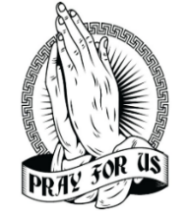
PLEASE PRAY for all our sick parishioners who are in nursing homes or housebound especially for John Petty, Alison Stainthorpe, Sami Ghazal, Sophie Reilly, John Heal, Sandra Waugh, Eileen Cross, Cherie Pay, Maureen Garson, Teresa Ford, Geraldine Lewis, Peter Hogan, Sr. Angela, Rosemary Gill, Asahi Religa, Keith Francis, Andy Renton, Canon Oliver Heaney, Alexander Cruickshank, Teresa Curtis, David Iddiols, Philip Roderick, Christine Talbot, Beau Harvey & Michael O’Brien. Please let the Parish Office know if you would like a name added.
PLEASE PRAY for the repose of the souls of all those recently deceased members of our parish, especially Peter McBride RIP and Louis Gaskin RIP, his funeral is on Tuesday 5th March 9:30am at OLOL Church. May they rest in peace. Please keep their families in your prayers.
PLEASE PRAY for the eight young people in our parish, aged 14-18, who are preparing for Confirmation this year.
Visits to the Sick/Hospital/Housebound: If you know of anybody who is sick please contact the Parish Office.
QUIZ NIGHT POSTPONED: Please note that the quiz night planned for the evening of Saturday 24 February has been postponed until after Easter.
CAFOD Family Fast Day appeal this weekend: This Lent, your donations to CAFOD’s Family Fast Day appeal will help hardworking people like James the fisherman in Liberia with resources, tools and training to feed their families for good. Give this weekend using the envelope in church or online at cafod.org.uk and please join us in praying with James that our sisters and brothers around the world have what they need to feed their families.
RCIA (Rite of Christian Initiation for Adults) course: Tuesday evenings from 6pm to 7pm in the Church Hall at OLOL.
Breakfast Club: CANCELLED THIS WEEK ONLY 29 Feb.

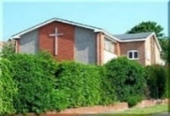
Stations of the Cross at St. Patrick's: During Lent we are having Stations of the Cross each Monday morning at 11am. During Holy Week we will have them on Good Friday. Many thanks to Larry for helping out.
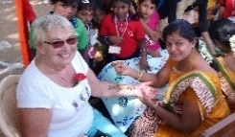
Lunch for The Kanji Project: Our ‘frugal’ lunch at 42 Ainsworth Ave Ovingdean, for The Kanji Project, on St. David’s day, is now fully booked. We hope to hold a buffet garden party in the summer. Meanwhile sales of homemade preserves from our porch continue with all funds going to Kanji. Bernadette and Ted
SAVE THE DATE – St Patrick’s Day Céilí: As usual in March in celebration of St. Patrick we are having a céilí with live music, caller and refreshments. This will be on the evening of Saturday 16 March at St. Patrick’s. 6pm start, £10 per adult, family tickets negotiable price, contact person: Bernadette (berskin@hotmail.com)
Friday 12 April PADERU 7pm Indian Dinner with Sr Shema and friends at OLOL Church Hall £25pp BYO drinks. Only 50 places available. Please pay cash direct to Prebytery in an envelope marked ‘Paderu’ with your full names on the envelope, tickets will also be available after mass on the weekend of 17/3 and 24/3. Donations for raffle prizes appreciated. Hand in to office. Funds being raised for ‘The promotion and restoration of human dignity of the marginalisaed communities in India.’ Thank you very much.
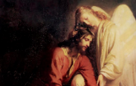
Resonance: Choral Music for Lent and Easter, Saturday 16 March at 1pm at St. Margaret’s Church, Rottingdean. Tickets £5 on the door.
Kaleidoscope: exhibition by the Society of Catholic Artists at the Grange Gallery, Rottingdean, from Wednesday 28 February to Sunday 10 March. Admission free. The Society of Catholic Artists aims to raise the standard of religious art. Their members have been responsible for major artistic works in cathedrals and churches throughout Britain.
“The Promise of the Father” is an exciting new course for Arundel and Brighton Diocese. The course is free and aims to help us to live our lives empowered by the Holy Spirit. It is held over seven sessions (starting 10 April, ending 23 May), each with a renowned speaker and small group discussions. For details and to book, see the Worthing and Lancing parish website.
Lay Community of St Benedict Lent programme: ‘Lift your hands to God in prayer’, 7.30pm Thursdays in Lent (22 and 29 February and 7, 14, and 21 March) on Zoom. Open to all! See the LCSB website for details and to register.
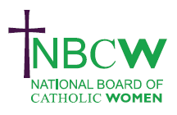
Parish news from the National Board of Catholic Women (NBCW):
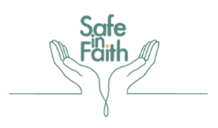
Safe in Faith is a project of Caritas Westminster. They are running free and low cost workshops on domestic abuse, trauma and faith throughout the year, starting in March. On Tuesday 12 March NBCW's Violence Against Women and Girls (VAWG) committee, along with the Caritas Social Action Network’s Domestic Abuse Alliance are hosting a webinar to launch Safe in Faith's signposting toolkit and the Faith and VAWG Coalition’s guidance for Faith Leaders responding to domestic abuse.
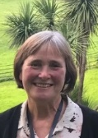
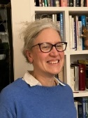
Inspiring Women webinar: ‘Women and Synodality’, Saturday 16 March, 11.00am to 12.45pm. Avril Baigent and Helen Burgess will explore the synodal journey and encounter the voice of women. Join as individuals or a Parish group. For Zoom link please contact nbcw@abdiocese.org.uk
~~~~~~~~~~~~~~~~~~~~~~~~~
The Parish Office is open to parishioners on Fridays from 8.30am to 12noon.

